
AGENT MANAGER GUIDE

motor vehicle payments
Oklahoma Tax Commission


Table of Contents

Chapter 1
Getting Started 3
Chapter 2
Search/Add New Users 4
Chapter 3
Transaction Report 7
Chapter 4
Reprint Receipt 8
Chapter 5
How to Process Payments 9
Chapter 6
How to Refund a Transaction 13
Chapter 7
How to Select a Printer 15
Chapter 8
Logging Out 16
Chapter 9
How to a Refund Partial Transactions…………………………………………………17

Getting Started
Chapter 1

The Oklahoma Tax Commission’s Motor Vehicle Payments system is designed to help provide a more convenient way for customers to pay for their motor vehicle tags. It allows for tag agents to accept Visa, MasterCard, American Express and Discover credit cards and branded Visa or MasterCard debit cards. The goal of this manual is to provide instructions on how to manage the motor vehicle payment system and process credit card payments.

Step 1: To access the Oklahoma Tax Commission’s Motor Vehicle Payments, type https://www.ok.gov/oktax/payment.

Step 2: The Motor Vehicle Payment login page will appear. Type in your login name and password assigned to you. Select ‘Submit’.
The first time you login, you will be required to change your password. The password must meet the following requirements:
1. The password must contain at least 8 characters.
2. The password must contain upper and lower case alpha characters.
3. The password must contain a number or a special character.

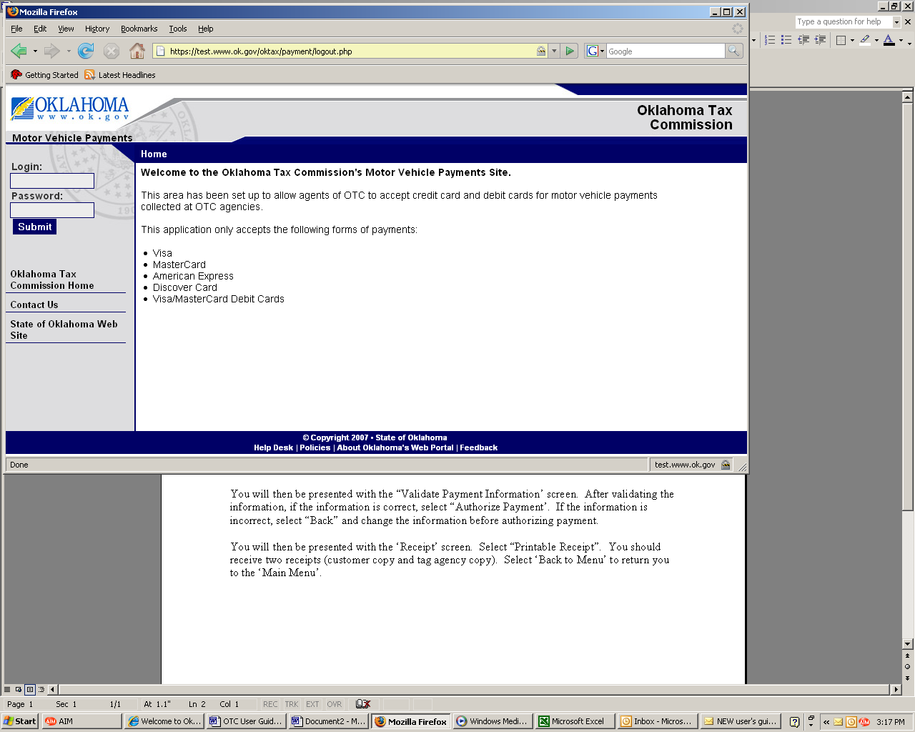

Search/Add New Users
Chapter 2

Step 1: To search for a user, select ‘Search/Add New Users’ from the Main Menu. Enter the search criteria and select ‘Search’.
NOTE: You can only display all active users by selecting ‘Yes’ and selecting the Search button.
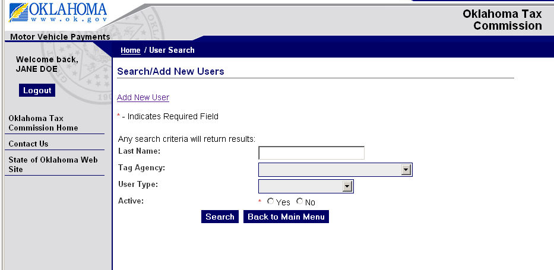

Step 2: The name will then appear allowing you to view, edit, reset the login or delete a user.

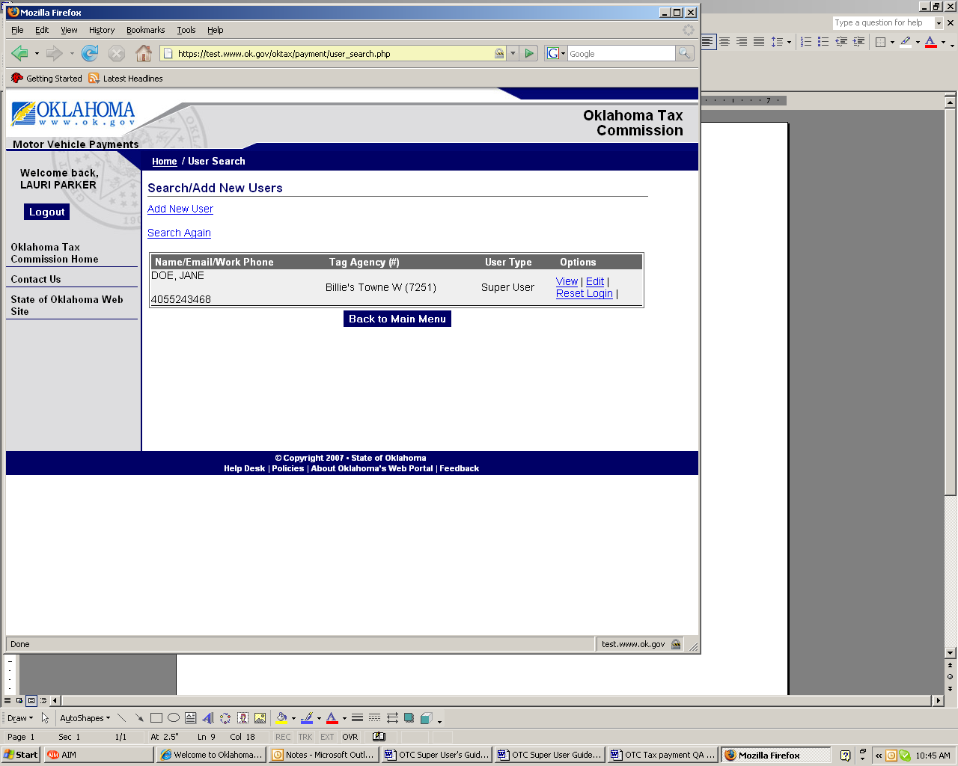

‘View’ allows you to view user information and security information. ‘Edit’ allows you to edit user information. ‘Reset Login’ allows you to reset the login information for a user. After verifying the user’s security questions, you can reset the user login and password.

Search/Add New Users
Chapter 2

Step 3: To add a new user, select ‘Add New User’.

A user marked as not active will not be allowed to log into the system.

NOTE: You can only search and add users from your agency.

Search/Add New Users
Chapter 2

Step 4: The ‘User Info’ screen will appear which will allow you to create a new user.

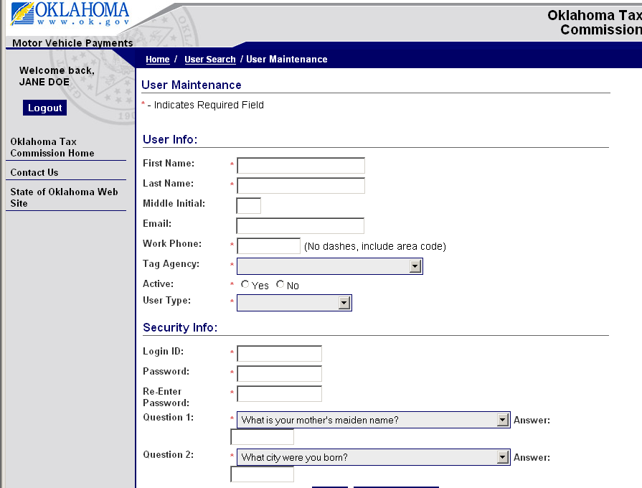

‘Active yes or no’ allows you to activate or inactivate a user.

User Types

Agent Manager - has rights to set up users, process and run reports within their agency.

Agent Restricted User – has rights to process payments.

NOTE: Security questions are case sensitive and will be saved exactly as they are entered. Please verify your answers and note the exact way you enter the answers.

Transaction Report
Chapter 3

Step 1: To create a transaction report, select ‘Transaction Report’ from the Main Menu. Select a report type and the date or date range. Select ‘Create Report’, Download to Excel or ‘Back to Main Menu’.

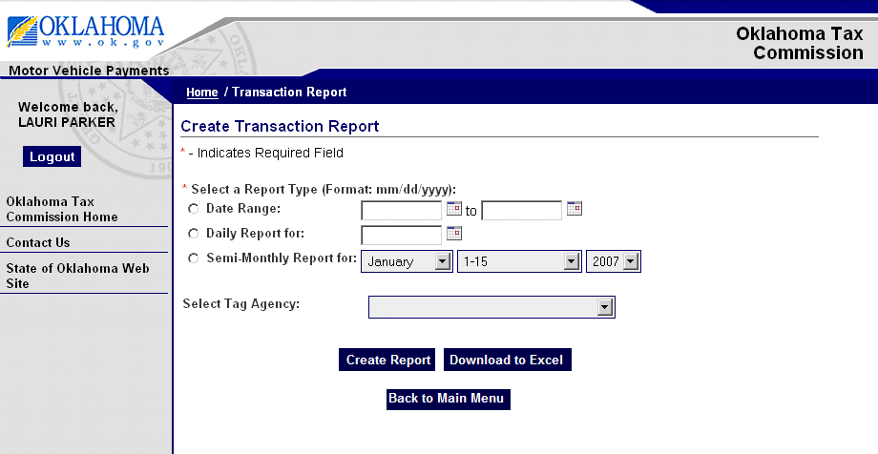

Step 2: The transaction report will appear. You can select ‘Printable Report’ to print the report or ‘Download to Excel. After running the report, select ‘Back to Main Menu’.

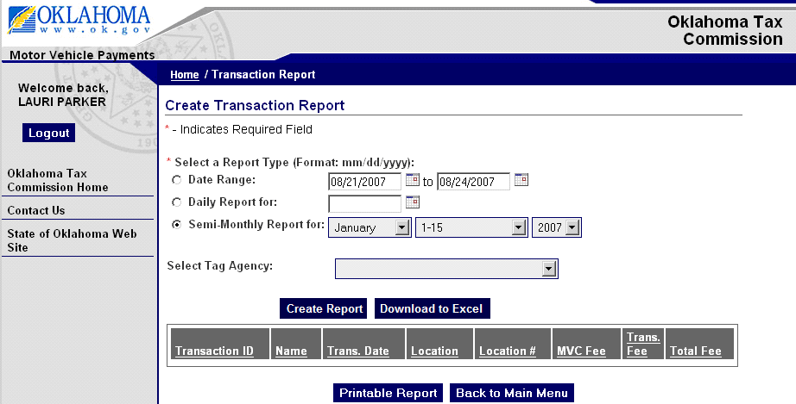

Reprint Receipt
Chapter 4

Step 1: To reprint a receipt, select ‘Reprint Receipt’ from the Main Menu. Select agency. You can enter the Transaction ID if you know it. If you do not know the Transaction ID, you can enter it. This field is optional. NOTE: The system will only reprint receipts from the agency that is logged into the system.

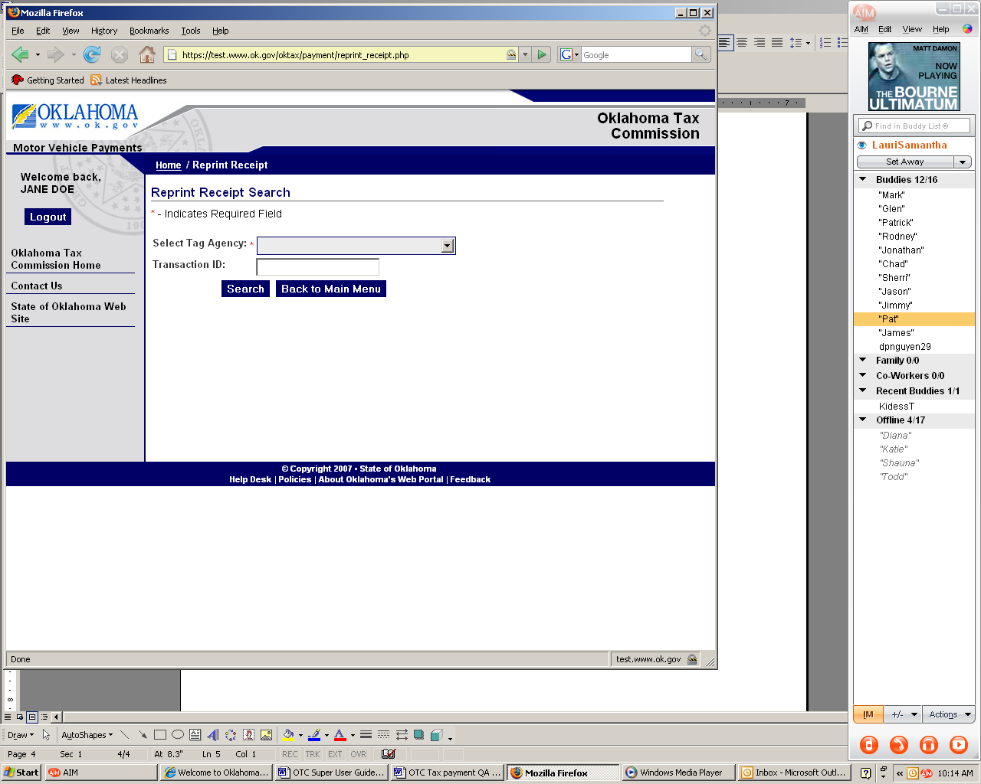

Step 2: Select the appropriate ‘Order ID#’ and then select ‘Reprint’. After printing receipt, select ‘Back to Main Menu’.

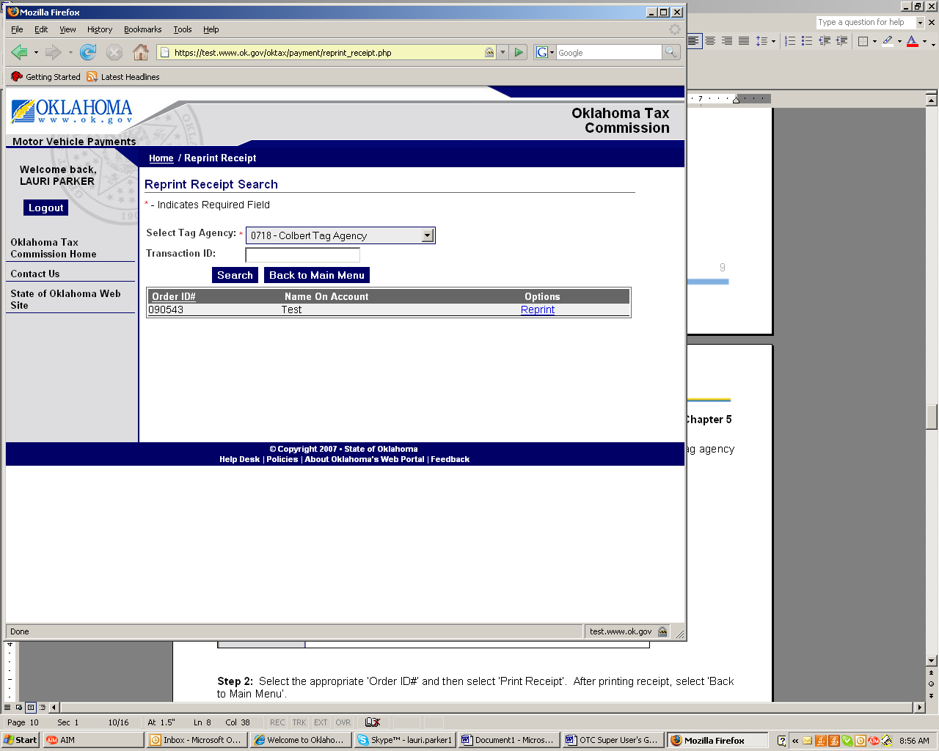

How to Process

Payments
Chapter 5

Step 1: Select ‘Process Payments’ on the Main Menu screen.

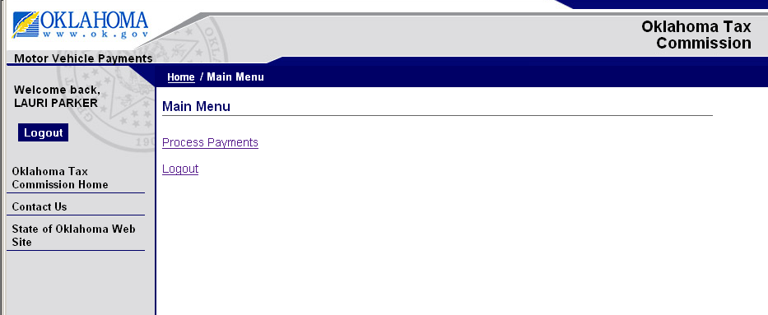

Step 2: If using the card swiper, verify the cursor is in the ‘Account Number’ field and swipe the card. If the cursor is not in the ‘Account Number’ field, use the mouse to click in the ‘Account Number’ box. You will have to manually enter the ‘CCV Number’ and ‘Amount’.
NOTE: If you are using the card swiper and the transaction fails, advise the customer to contact their card company and not the Tax Commission or OK.gov.
If entering manually, enter the ‘Account Number’, using the attached keyboard, without spaces or dashes. Enter the “Name on Account’. Enter ‘Payment Type’ and ‘Expire Date’ via the dropdown list. Enter ‘CCV Number’ and ‘Amount’.
NOTE: If you are manually entering the transaction using the keyboard and the transaction fails, try to reenter the transaction. If the transaction fails again, advise the customer to contact their card company and not the Tax Commission or OK.gov.

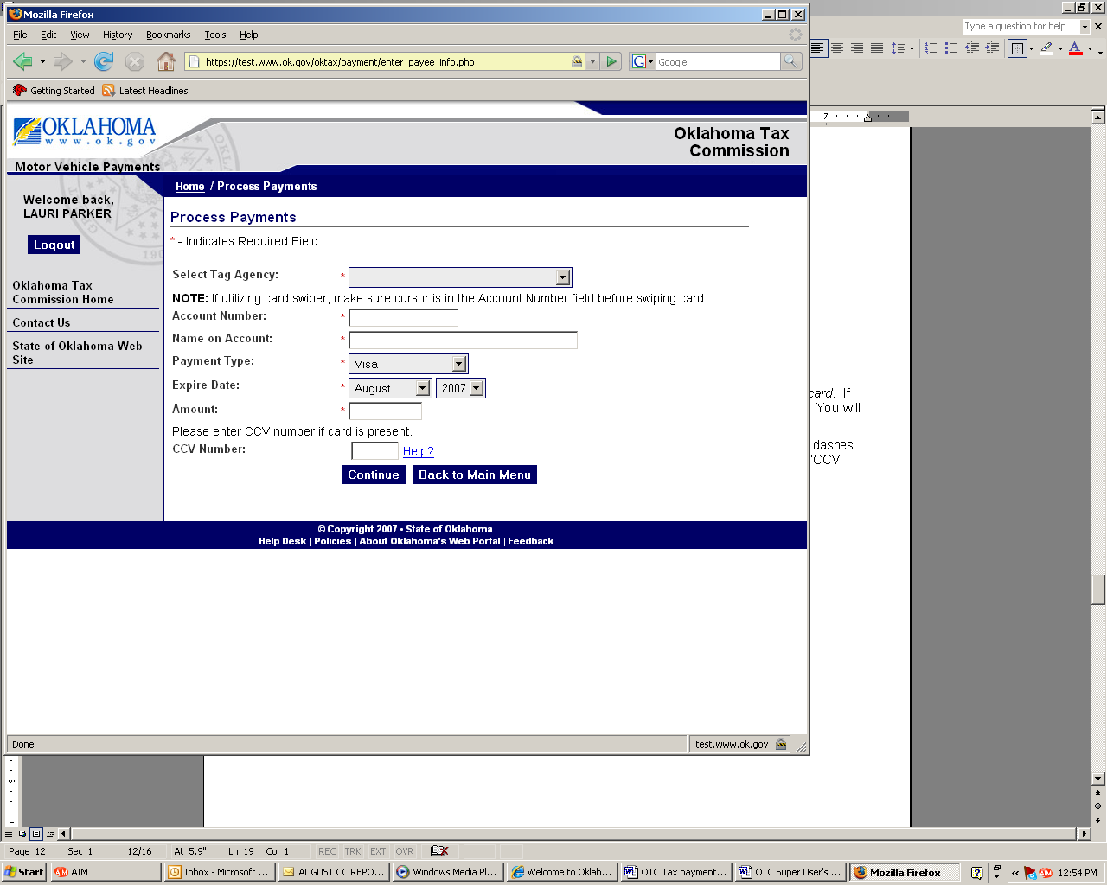

How to Process

Payments
Chapter 5

Step 3: If you need help identifying the ‘CCV Number’, select ‘Help?’ and a pop up window will appear displaying instructions on how to obtain the ‘CCV Number’. Select ‘Close Window’ to close the window.

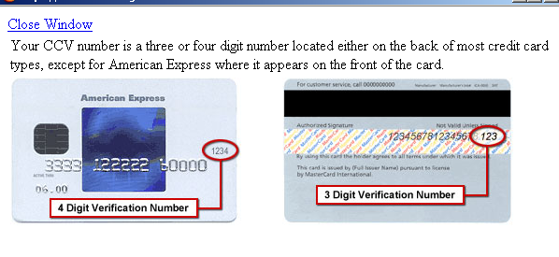

Step 4: After completing all the fields, select ‘Continue’ to confirm information. Select ‘Back to Main Menu’ to return to the main screen.

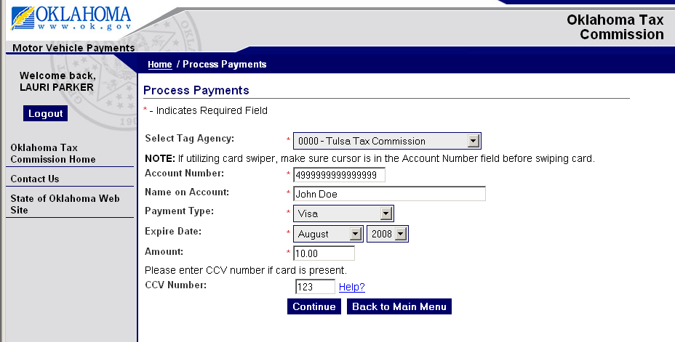

How to Process

Payments
Chapter 5

Step 5: After selecting ‘Continue’ a screen will appear displaying customer and payment information.
Verify that all information is correct. If information is not correct, then select ‘Back‘ to update the information. If information is correct, select ‘Authorize Payment’.

NOTE: Once you select authorize payment, please do not hit the refresh or back button on your browser window during the payment process. Please allow up to 60 seconds for this transaction to finish. Do not hit the authorize payment button more than once as the card may be charged multiple times.

Once the process has completed, a receipt page will be provided for you to print.

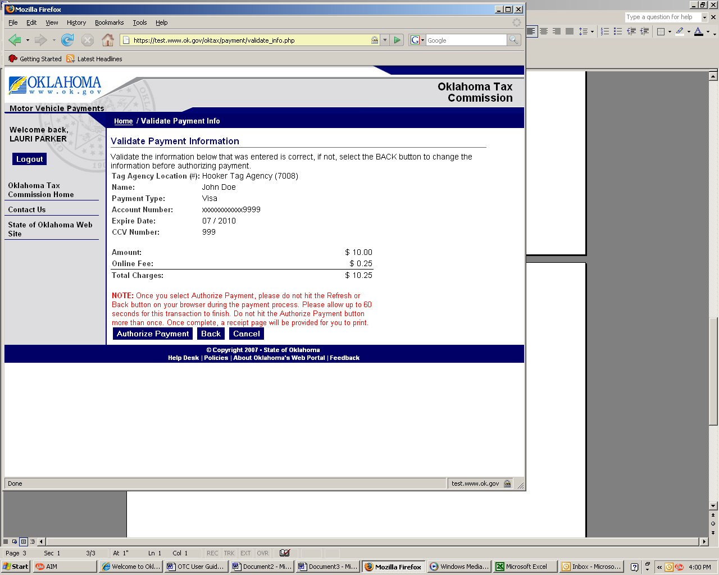

Step 6: After the payment has processed, the ‘Receipt’ screen will appear. Select ‘Printable Receipt’ to print
two copies of the receipt: 1) Tag Agency Copy and 2) Customer Copy. If printed on a PC Printer, the two
copies will be printed on a single page. If printed on a Terminal Printer (roll printer), the receipt will only print the amount. Select ‘Back to Main Menu’ to return to the main screen.

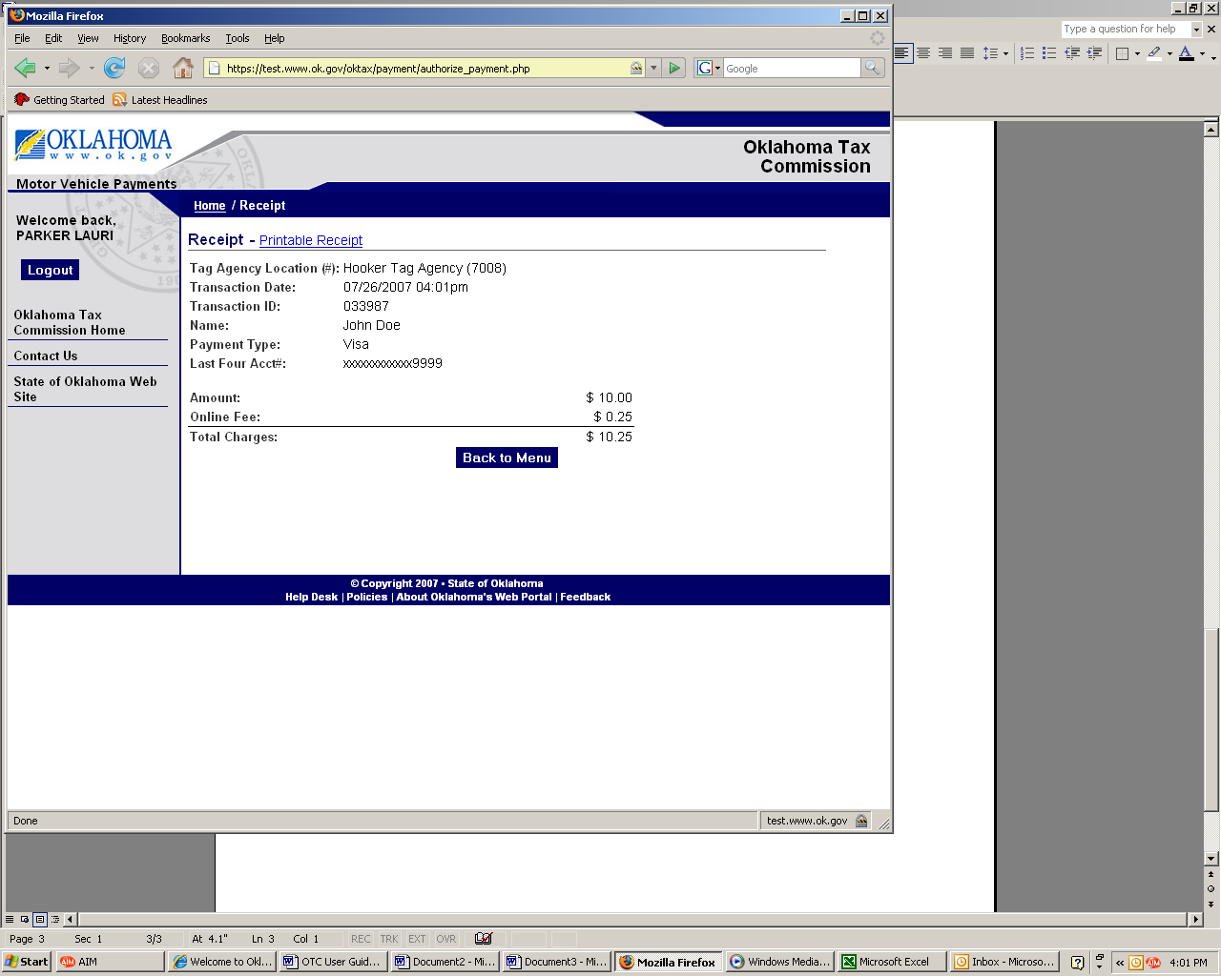

How to Process

Payments
Chapter 5

Step 7: The printable receipt will appear in a pop up window and will automatically prompt the print command on your computer. If your computer does not automatically print, then select ‘Print Receipt’. Select ‘Close Window’ to close the receipt window.

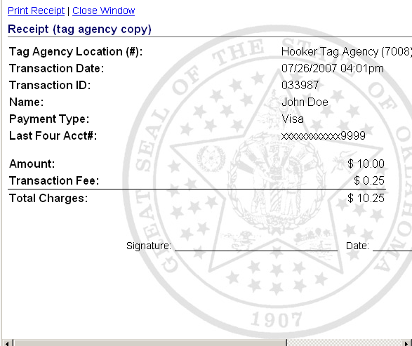

How to Refund a

Transaction
Chapter 6

Step 1: Select ‘Refund a Transaction’ on the Main Menu screen.

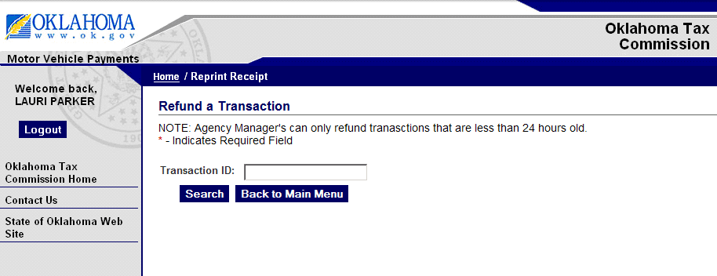

Step 2: You can enter the Transaction ID and select the Search button. This field is optional. If you do not enter a Transaction ID and select the Search button, it will display all transactions.

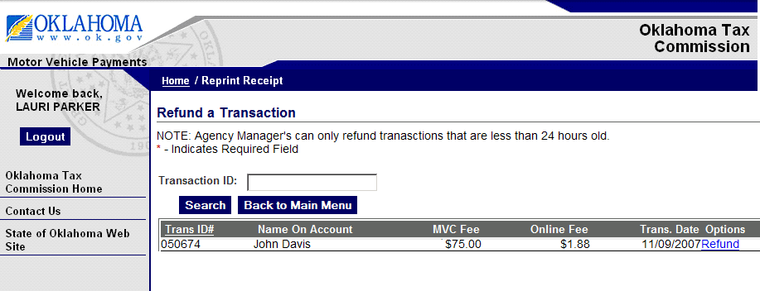
Step 3: Select the Refund link for the Transaction you wish you refund.

Note. The customer has a 24 hour span for a refund. The refund option will not be available if the 24 hour
limit has exceeded. Only full refunds will be allowed.

How to Refund a

Transaction
Chapter 6
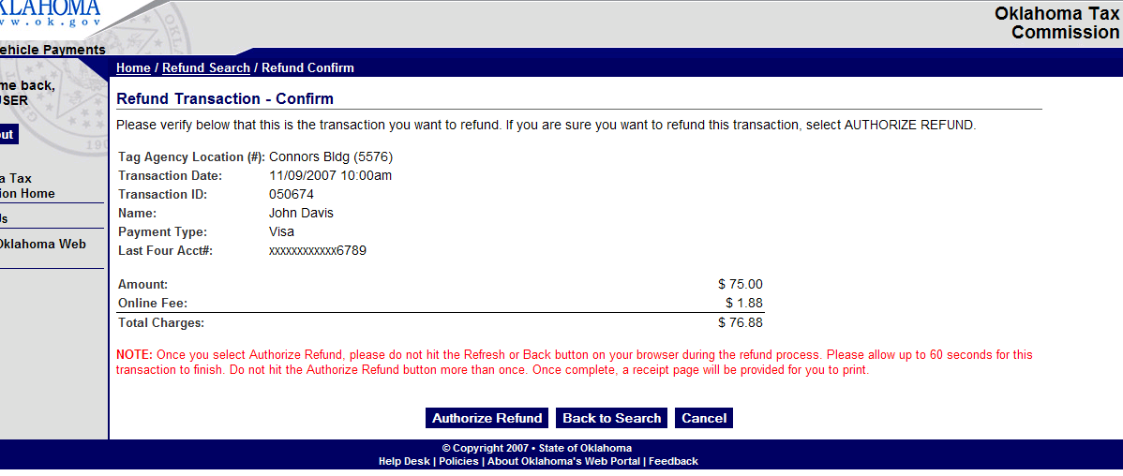

Step 4: After selecting ‘Refund’, the Refund Transaction confirmation page will display.

Verify that all information is correct. If information is correct, select ‘Authorize Refund’.

NOTE: Once you select authorize refund, please do not hit the refresh or back button on your browser window during the payment process. Please allow up to 60 seconds for this refund to finish.

Once the refund has completed, a receipt page will be provided for you to print.

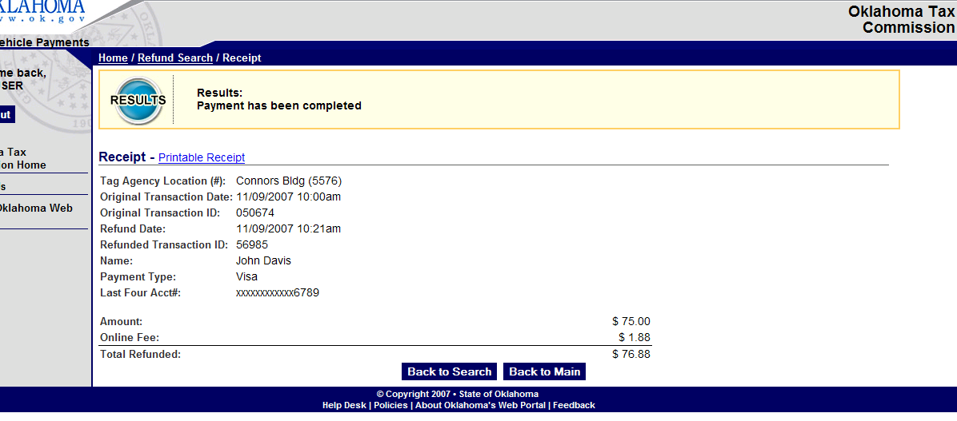

Step 5: After the refund has processed, the ‘Receipt’ screen will appear. Select ‘Printable Receipt’ to print
two copies of the receipt: 1) Tag Agency Copy and 2) Customer Copy. If printed on a PC Printer, the two
copies will be printed on a single page. If printed on a Terminal Printer (roll printer), the receipt will only
print the amount. Select ‘Back to Main Menu’ to return to the main screen.

How to Select a

Printer
Chapter 7

Step 1: Select ‘Select Printer’ on the Main Menu screen.
Step 2: Select Printer Type.
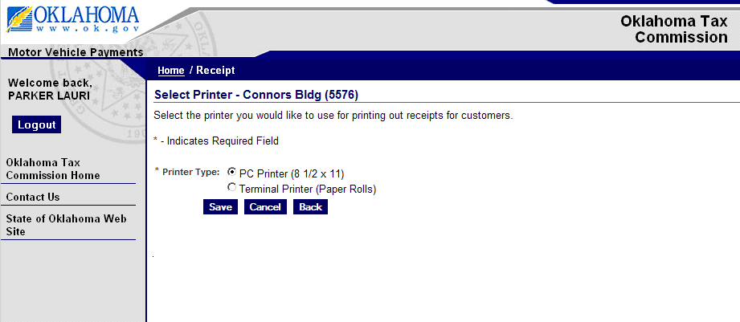
Step 3: Select Save to save the changes.

NOTE: If terminal printer is selected the transaction reports will not provide transaction detail, it will contain summary information only.

Logging Out
Chapter 8

Step 1: To logout of the Motor Vehicle Payment system, select ‘Logout’.

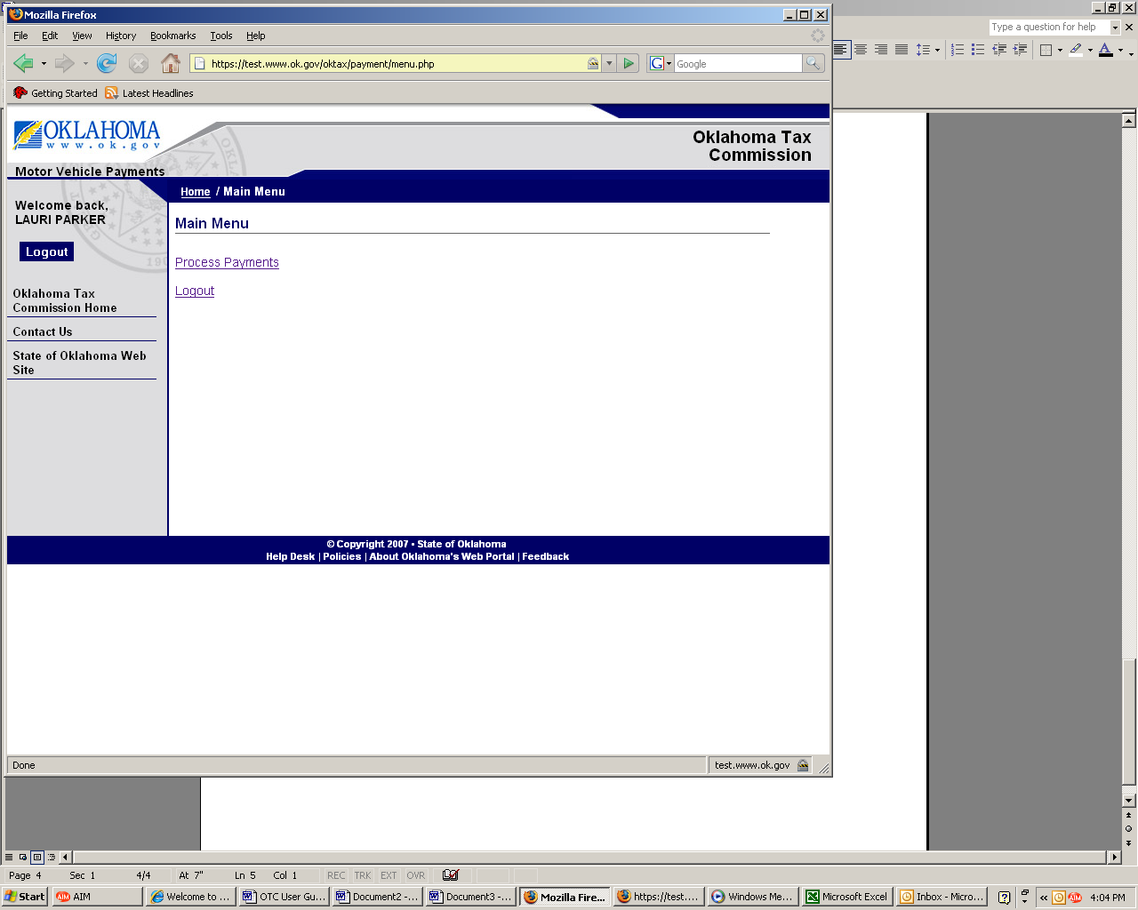

Step 2: After logging out, the Motor Vehicle Payments welcome page will appear.

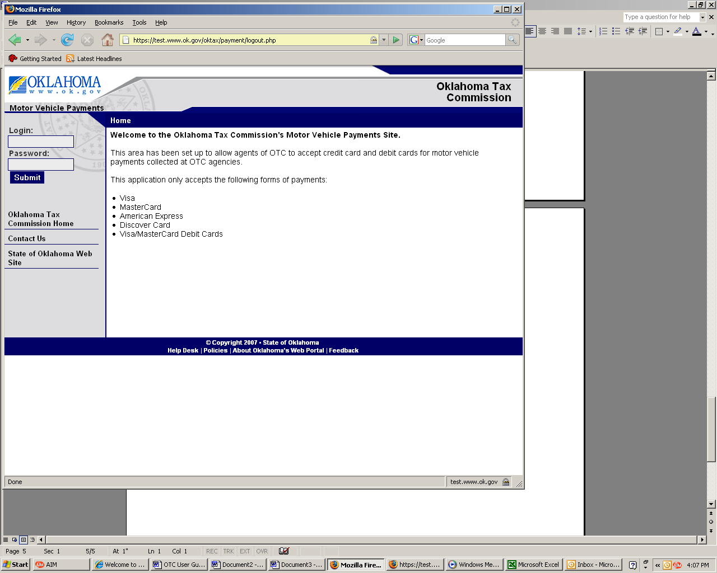

How to a Refund Partial Transactions
(Transactions stuck in processing and never completed)

Step 1: Select Refund Partial Transactions from the Main Menu

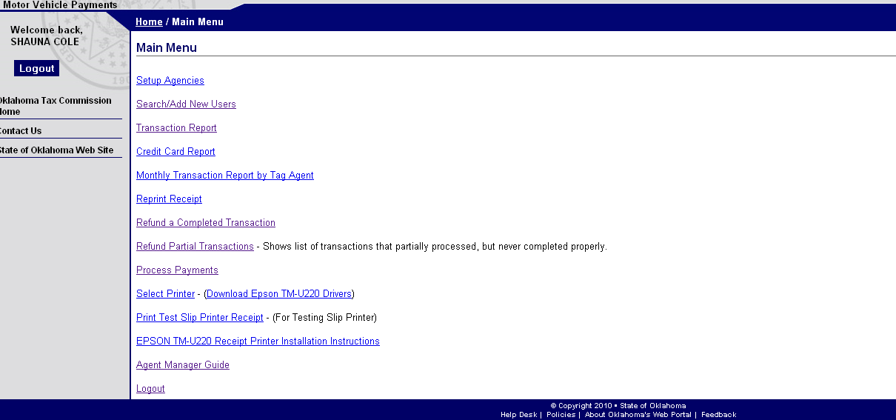

Step 2: Select Tag Agency and Search

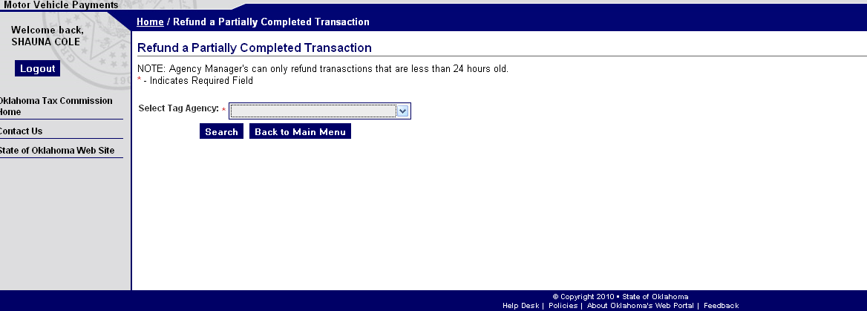

Step 3: Select Refund

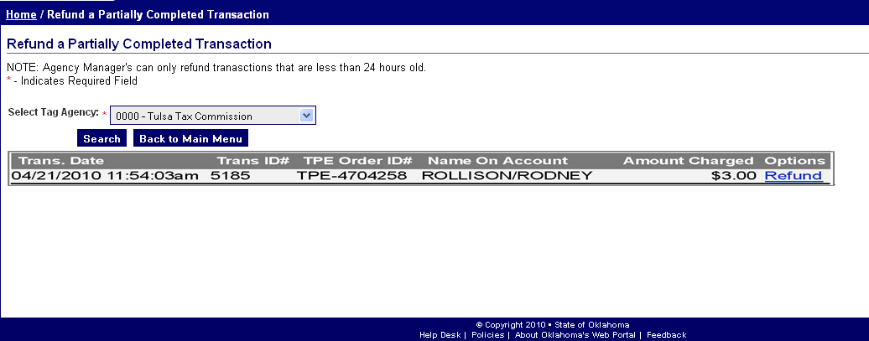

Step 4: Authorize Refund

Oklahoma Tax
Commission
Motor Vehicle Payments

Refund Partial Transaction – Confirm

The transaction below was processed through our payment module but not completed back to your Tag
Agency. Once refunded, it will no longer show on your partial refund list, nor will it show up on any of your
transaction reports.
Please verify below that this is the transaction you want to refund. If you are sure you want to refund this
transaction, select AUTHORIZE REFUND.

Tag Agency Location (#): Tulsa Tax Commission (0000)
Transaction Date: 04/21/2010 11:54:03am
Transaction ID: 5185
TPE Order ID: TPE-4704258
Name: ROLLISON/RODNEY
Last Four Acct#: V***********4444

Amount: $ 3.00 Total Charges: $ 3.00

NOTE: Once you select Authorize Refund, please do not hit the Refresh or Back button on your browser during the
refund process. Please allow up to 60 seconds for this transaction to finish. Do not hit the Authorize Refund button
more than once. Once complete, a receipt page will be provided for you to print.

Step 5: Receipt Page

Oklahoma Tax
Commission

Motor Vehicle Payments

Results: Payment has been completed
Refund Receipt

Print Receipt

Tag Agency Location (#): Tulsa Tax Commission (0000)
Original Transaction Date: 04/21/2010 11:54:03am
Refund Transaction Date: 21/04/2010
Original Transaction ID: 5185
TPE Order ID: TPE-4704258
Name: ROLLISON/RODNEY
Last Four Acct#: V***********4444

Amount: $ 3.00 Total Refunded: $ 3.00

Ste

Ste

